ECE 358 Computer Network Introduction

1.1 What is the Internet?

We are going to use two definitions

1. Using the hardware and the software that makes up the Internet
2. We are going to look at the Internet as an infrastructure that provides services to networking applications.

-The internet consists of millions of computing devices interconnected together

-These computing devices are called end systems = hosts

-Different transmission links will have different transmission rate

-The transmission rate of a link is measured in bits/secs (bandwidth)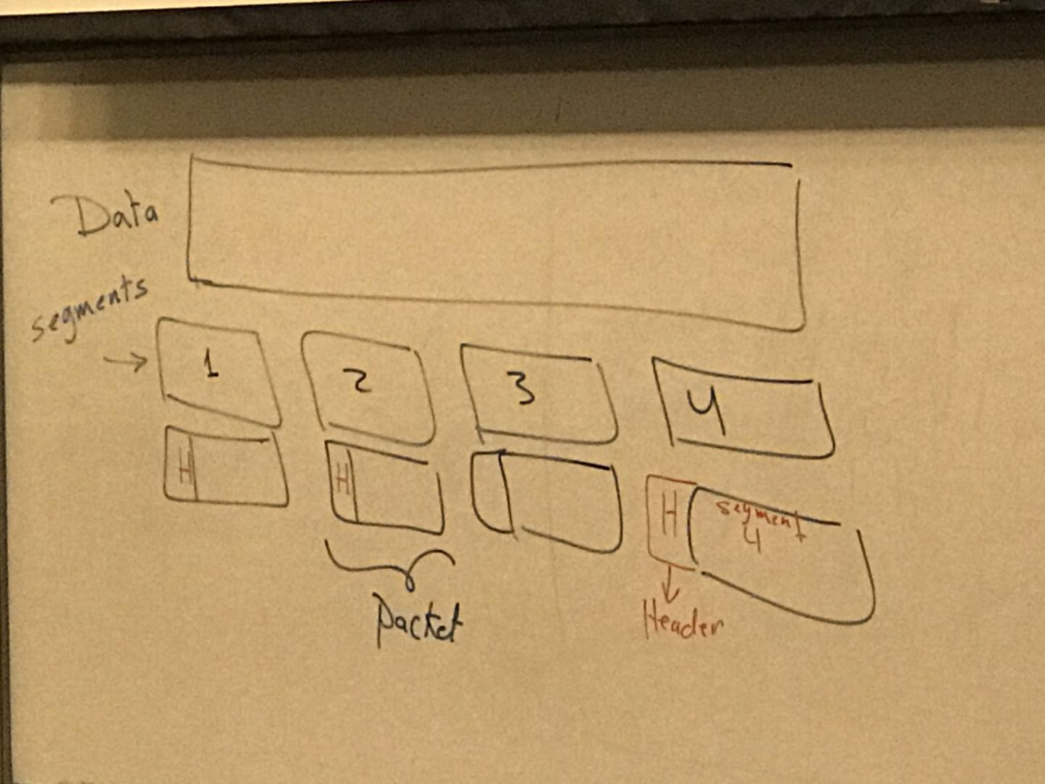

(Header used to track sender and receiver)

ISP = Internet service provider.

Protocols plays an important role in any computer network.

-In the Internet we have two important protocol

1. TCP :Transmission control protocol

2.IP: Internet protocol

-End Systems have to speak the same language. (same protocol)

-Due to the importance of protocols in the Internet. The Internet protocols are regulated by Internet Engineering Task Force(IETF)

-The standards created by IETF are called Request for comments(RFC)

Application Programming Interface

(API)

APPLICATION <- API -> INTERNET

You need to have API to use the Internet infrastructure services.

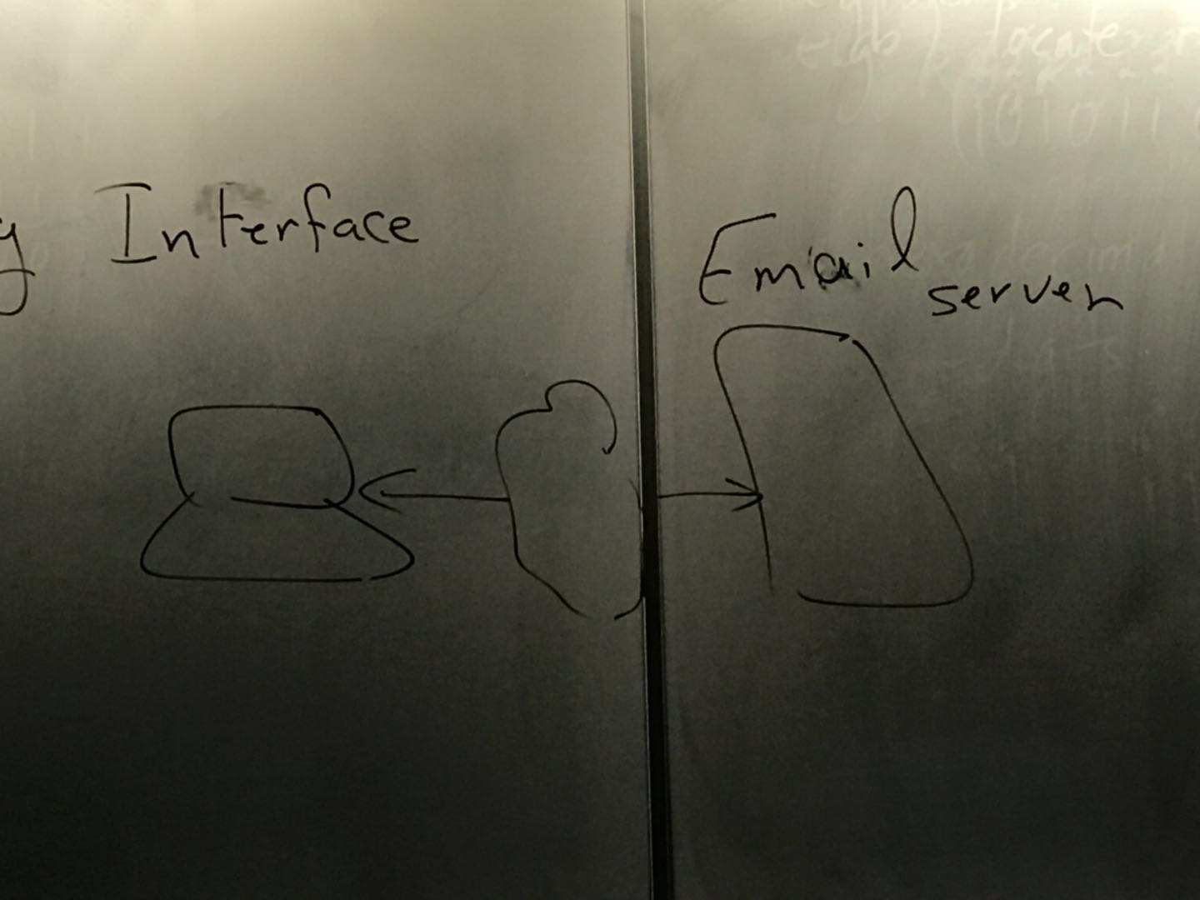

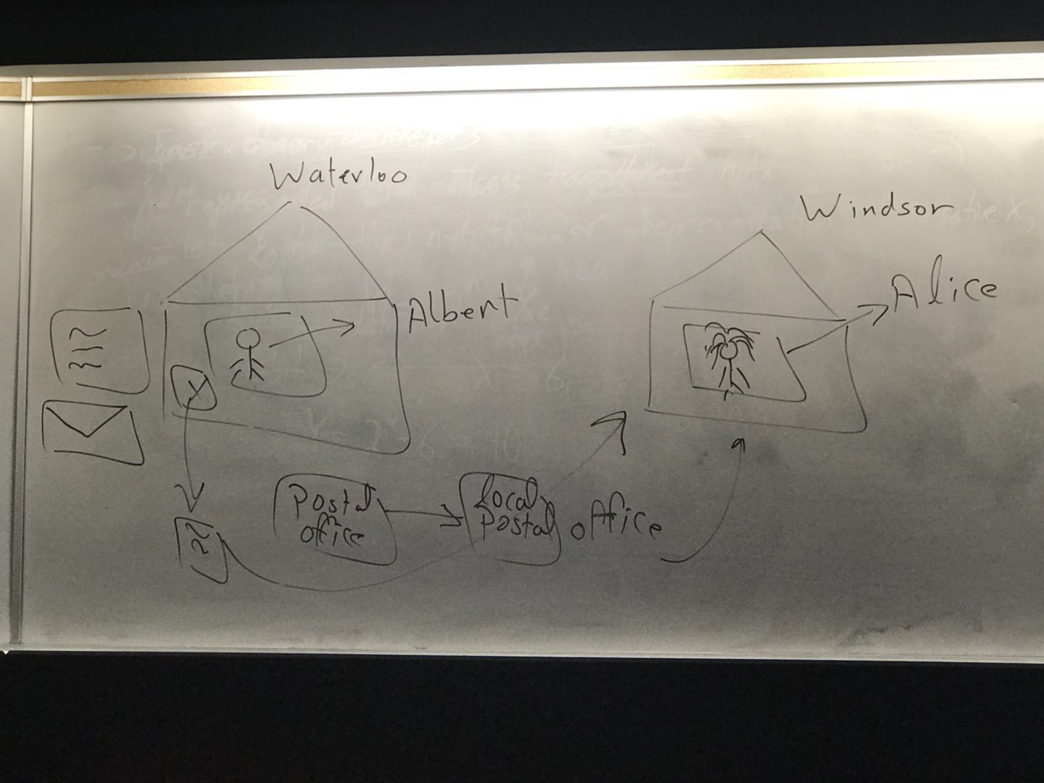

1.2 Network Edge

End systems or hosts reside at the edge of the network.

End system = hosts, we call computer hosts because they host (run) application program.

End system:

1. Clients
2. Servers ( more powerful)

-Access Network is the network that connects and systems to the first router connected to the internet.

-Different links will have different transmission rates( bits per second)(bps)(bandwidth)

Access net: digital subscriber Line (DSL)

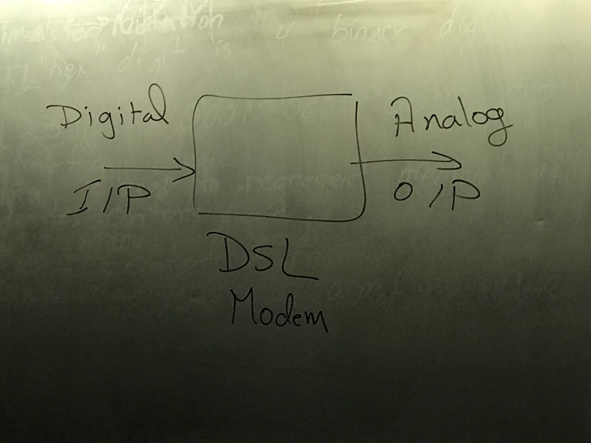

Speed is related to the frequency band. The total bandwidth is the same, upstream and downstream speed depends on the amount of resource that you split.

LAN -> local area network

- most common type of Lan is called Ethernet

Unshielded twisted pair (UTP) is the most common physical medium used now days.

Optical fiber cable properties

* Immune to interference
* Very low attenuation
* Sercurity ( they cannot be tapped)

1.3 network core

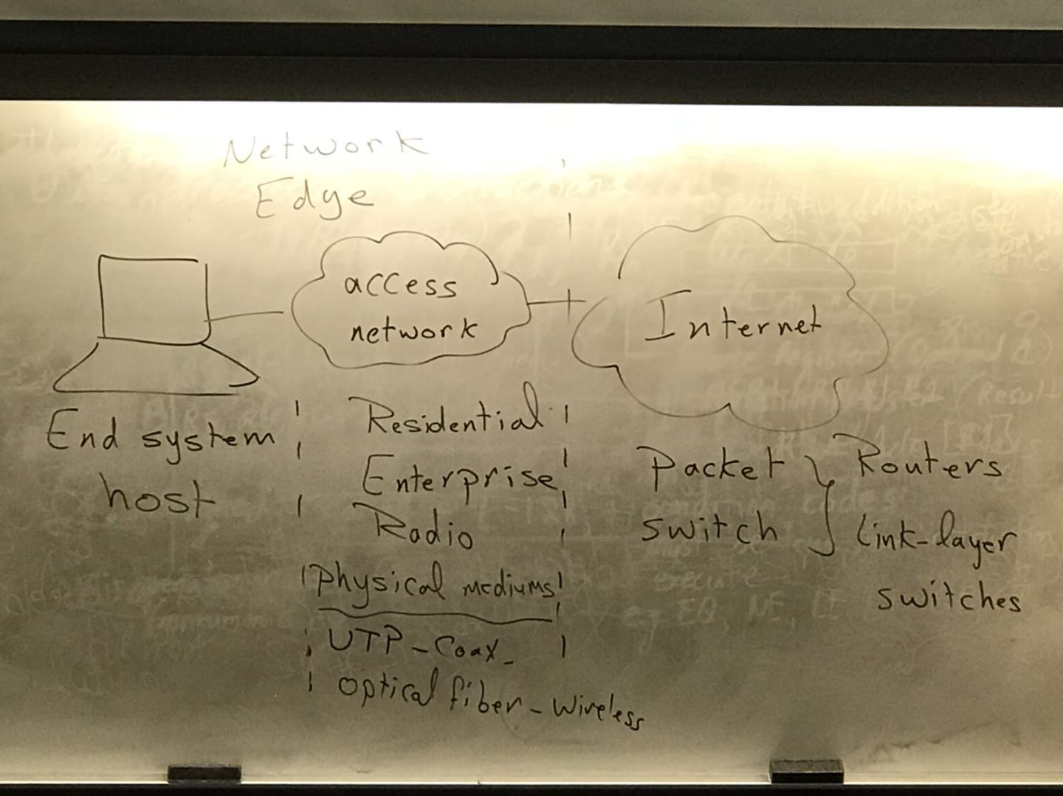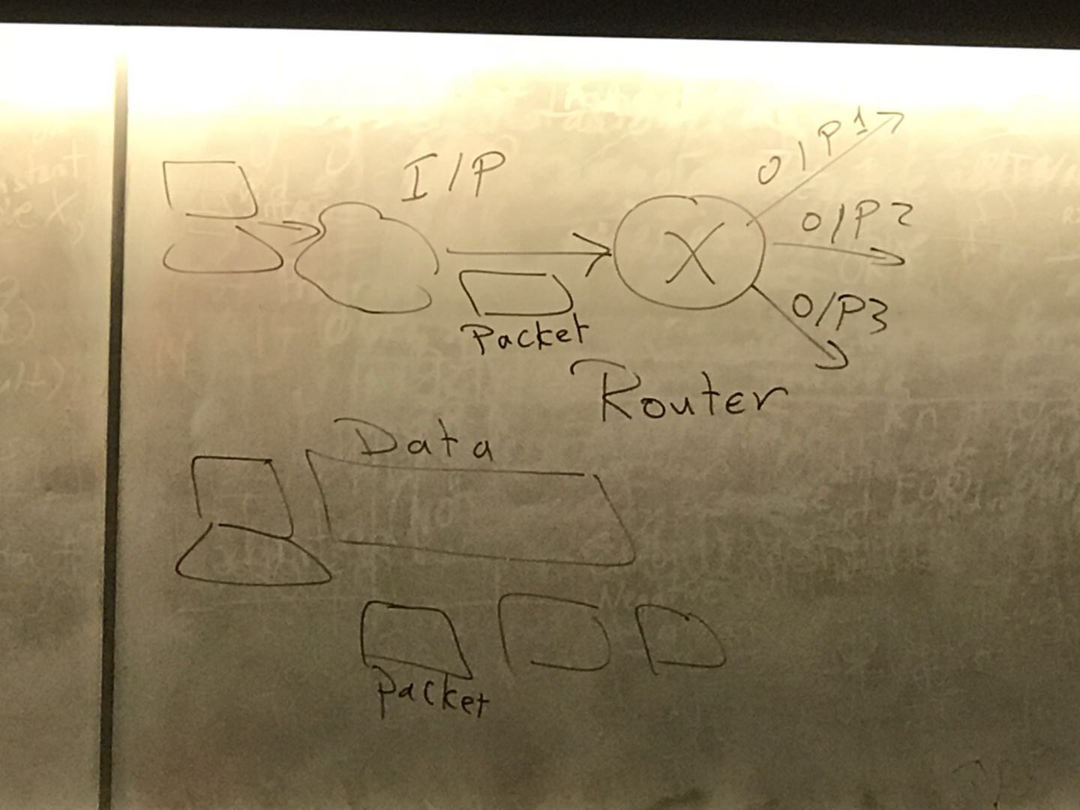

Store and forward -> the router has to wait until it receives the complete packet before it can forward this packet through one of its output links.

Example of calculating the packet transfer time:

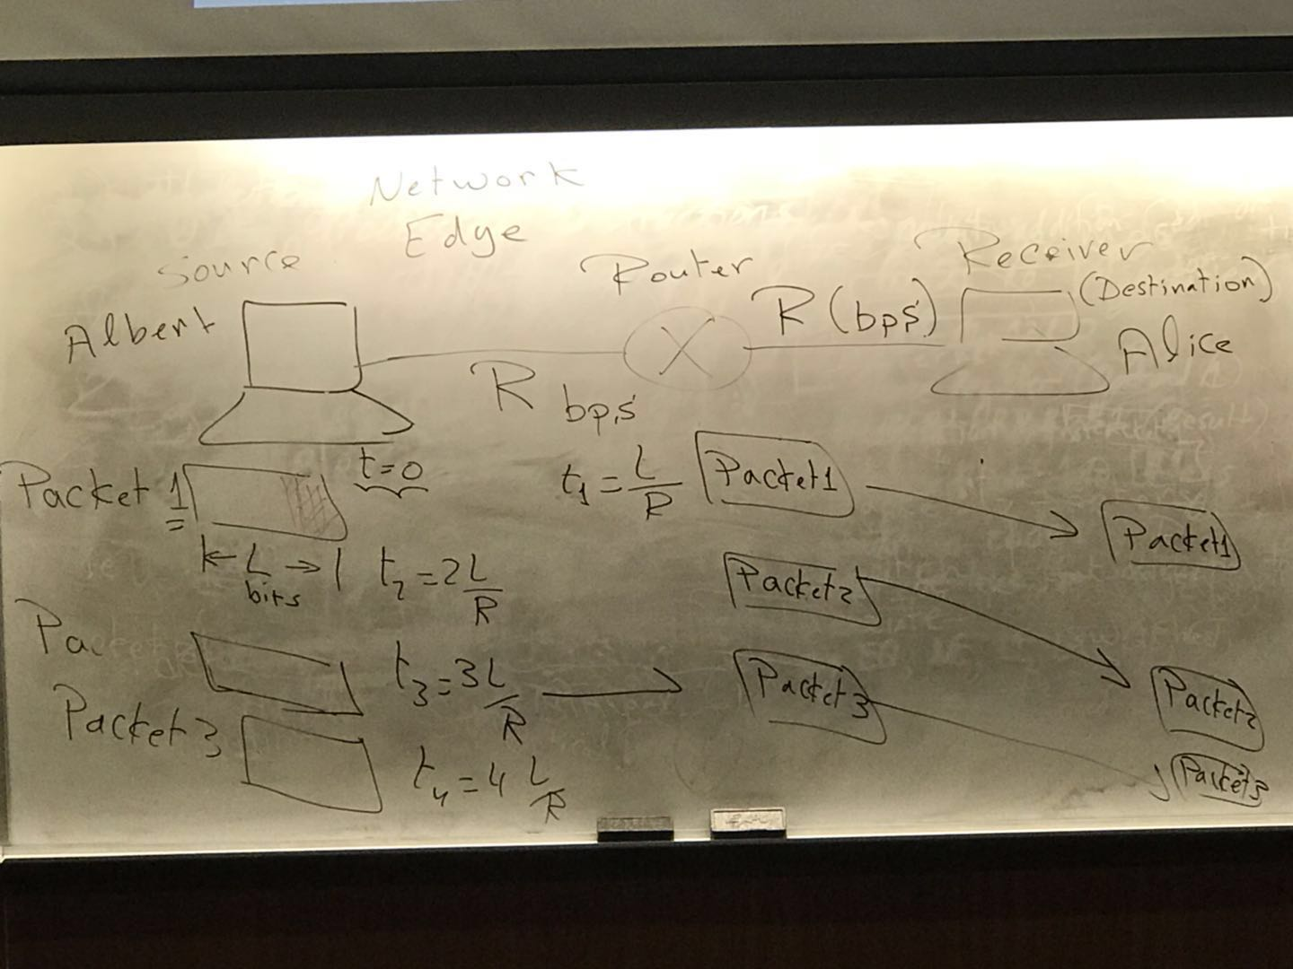

Packet loss

The queuing delay is the time that a packet has to wait until its turn to be transmitted

Packet loss: when a packet arrives at a full queue, it will be dropped(lost)

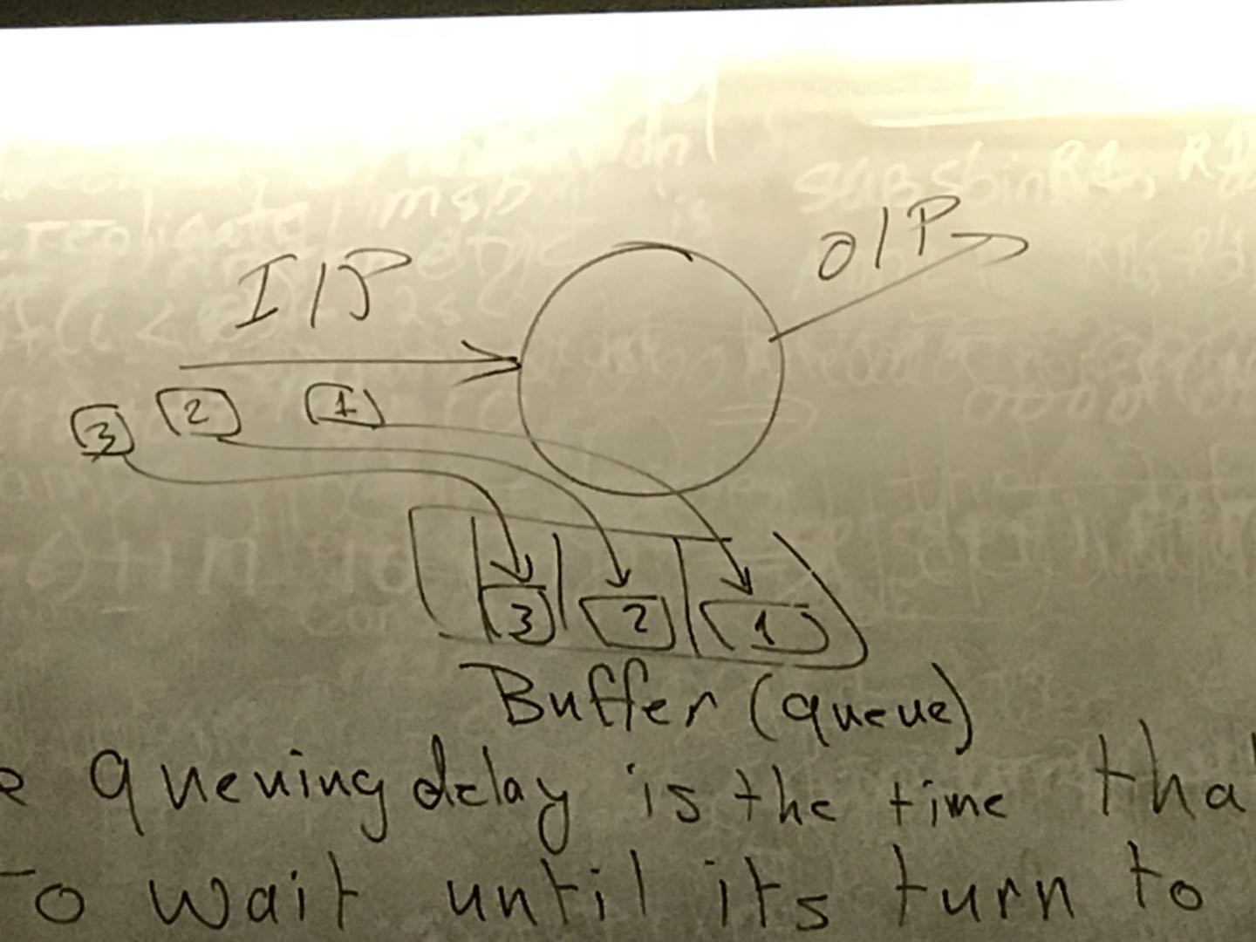

The address of the receiver(IP address) contains information about how to reach the receiever.

Circuit switching: FDM versus TDM

FDM: Frequency Division Multiplexing

TDM: Time Division Multiplexing

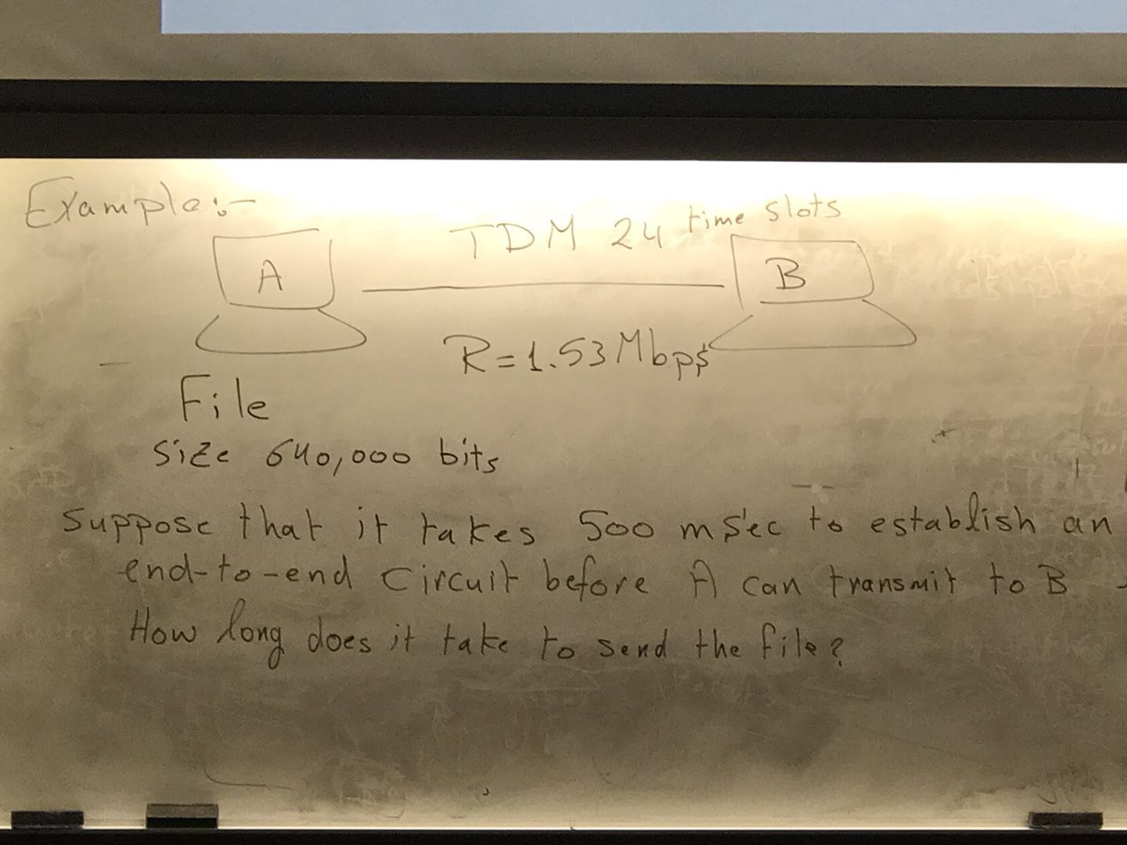

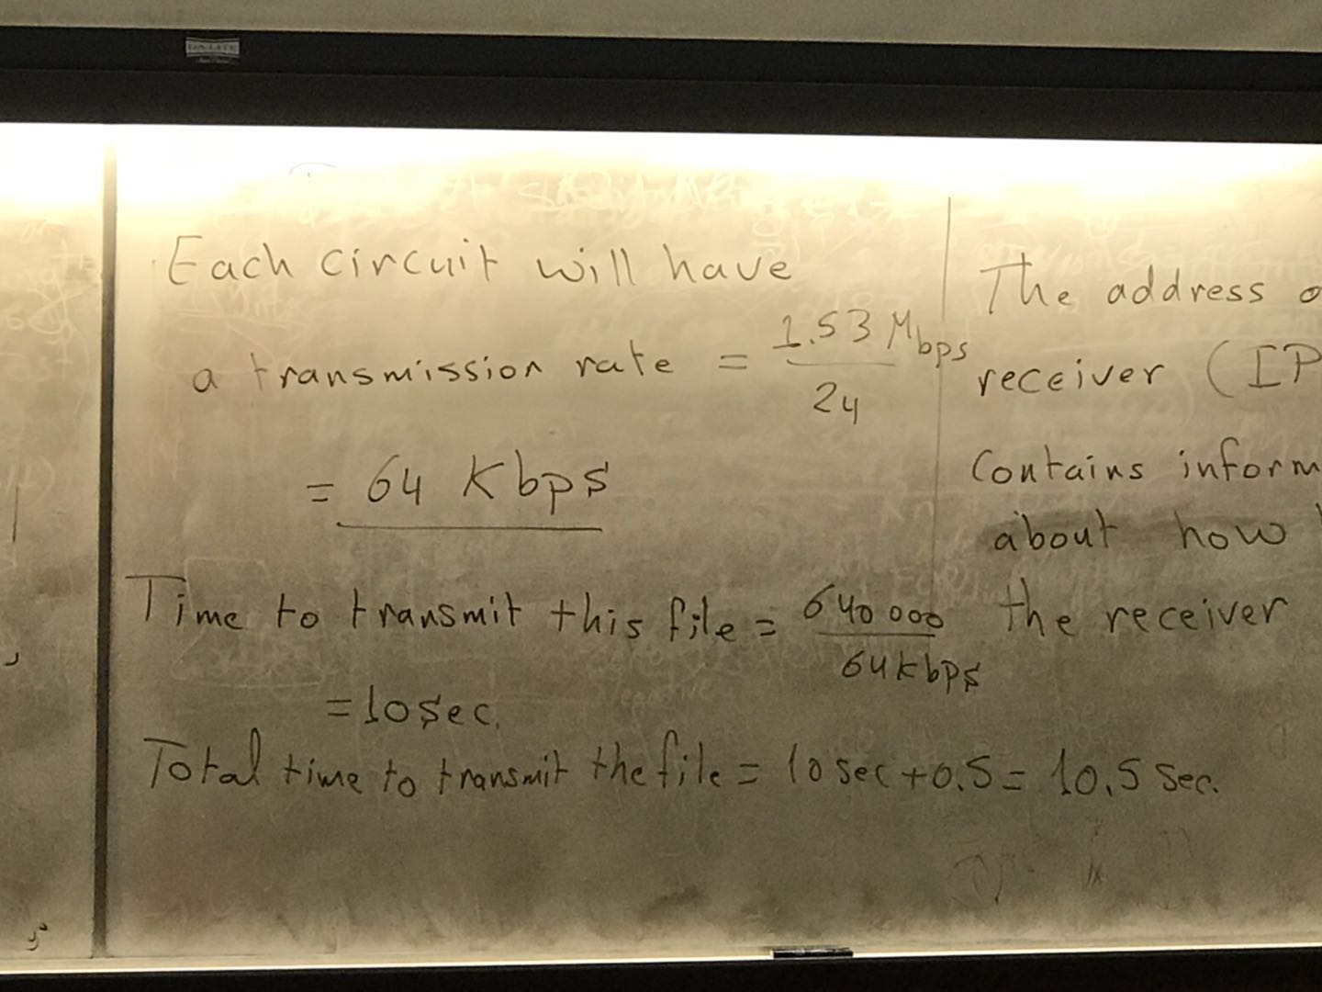

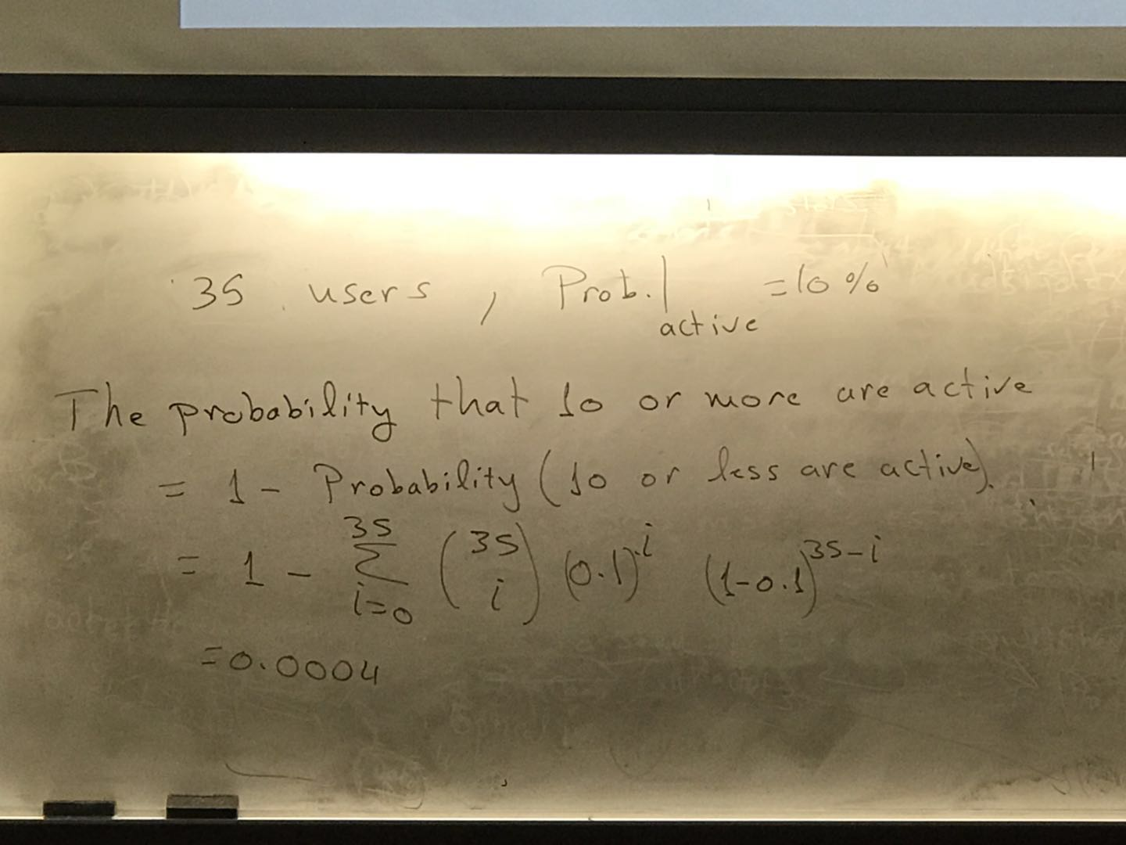

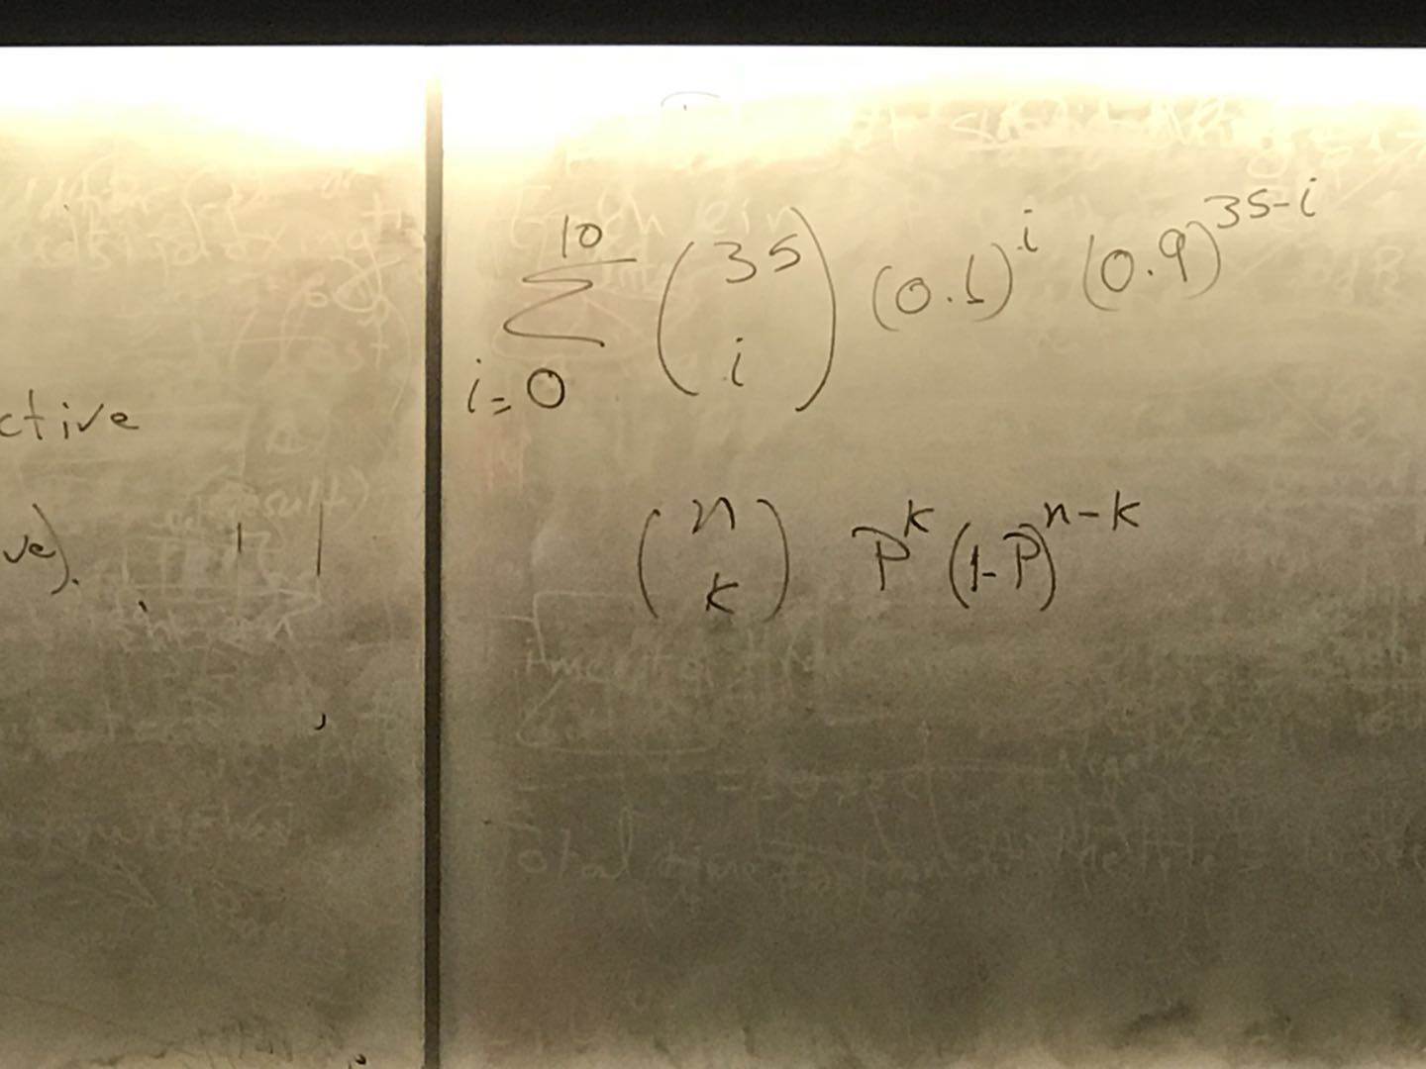

Caravan analogy

Ten-car caravan represents the packet, and the toll booth is the router.

More: propagation delay for one car = 100Km/1000Km/hr =0.1hr = 6min

Service time per car is = 1min, 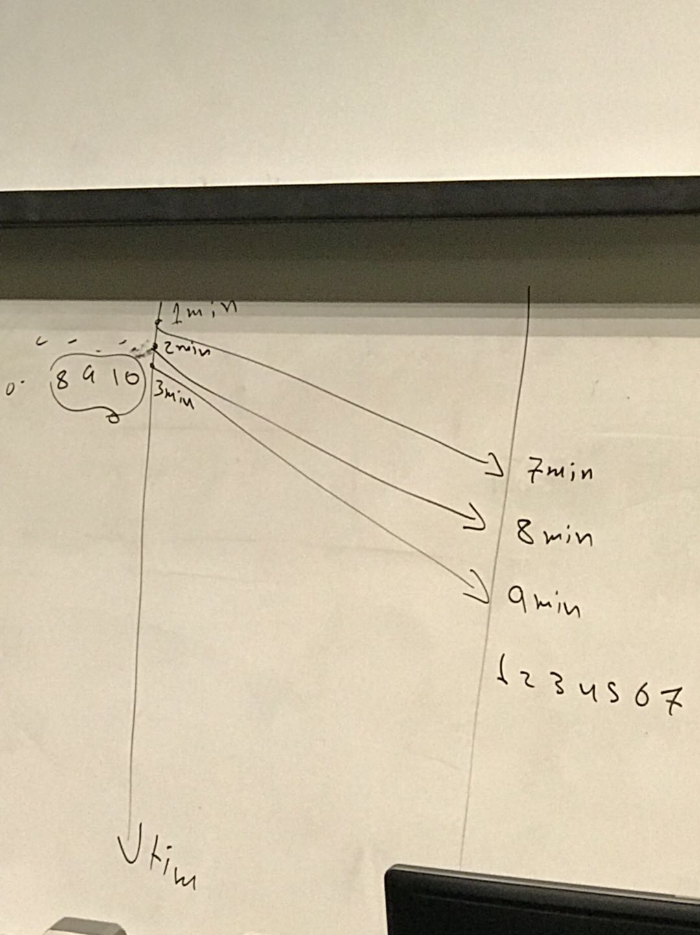

Queueing delay:

La/R , La is going to tell how many bits I will receive per second.

R is how many bits I can take out per second.

This is known as traffic intensity.

Jan 12

Protocol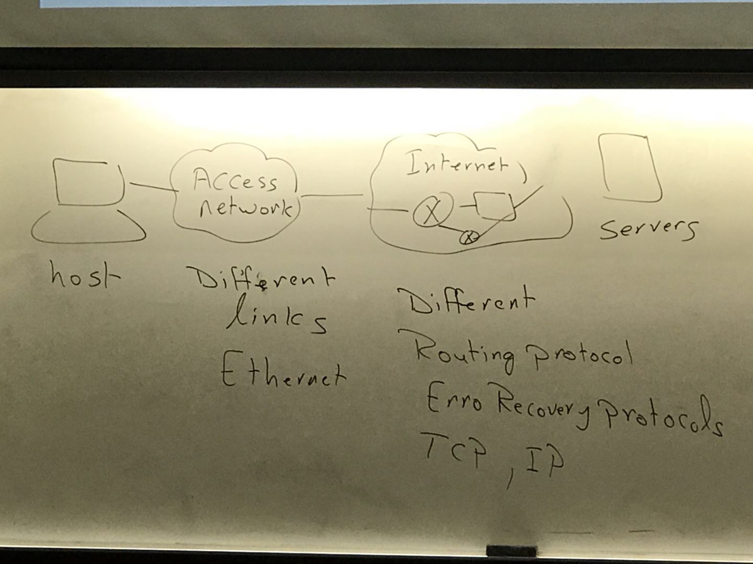

In order to organize computer network. Network designers organizes any computer network in a larger approach.

* The main concept is that

1. Each layer will perform a specific service (services model)
2. Each layer will depend on the services provided by the lower layers.

Advantages:

-Modularity

is layering harmful?

1. Some functions can be implemented by more than one time by different layers.

Transport layer is responsible for delivering of data between end systems(end to end communication) (ex preparation,)

Network plan the route of the router

Link happens internally in A and B

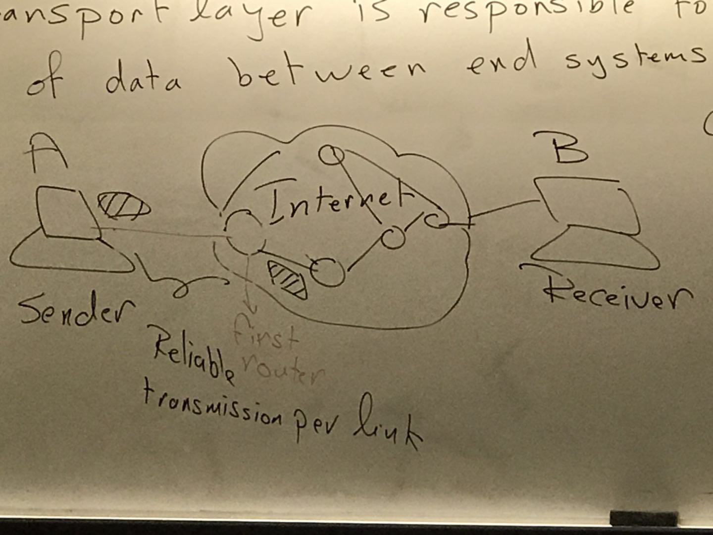

TCP: transmission control protocol.

UDP: User datagram protocol

OSI: open system interconnection

-OSI model was provided in the early days before the internet.

Encapsulation means that each layers will consider the packet coming from an upper layer as its own payload ( message) and it will attach its own header to the payload.

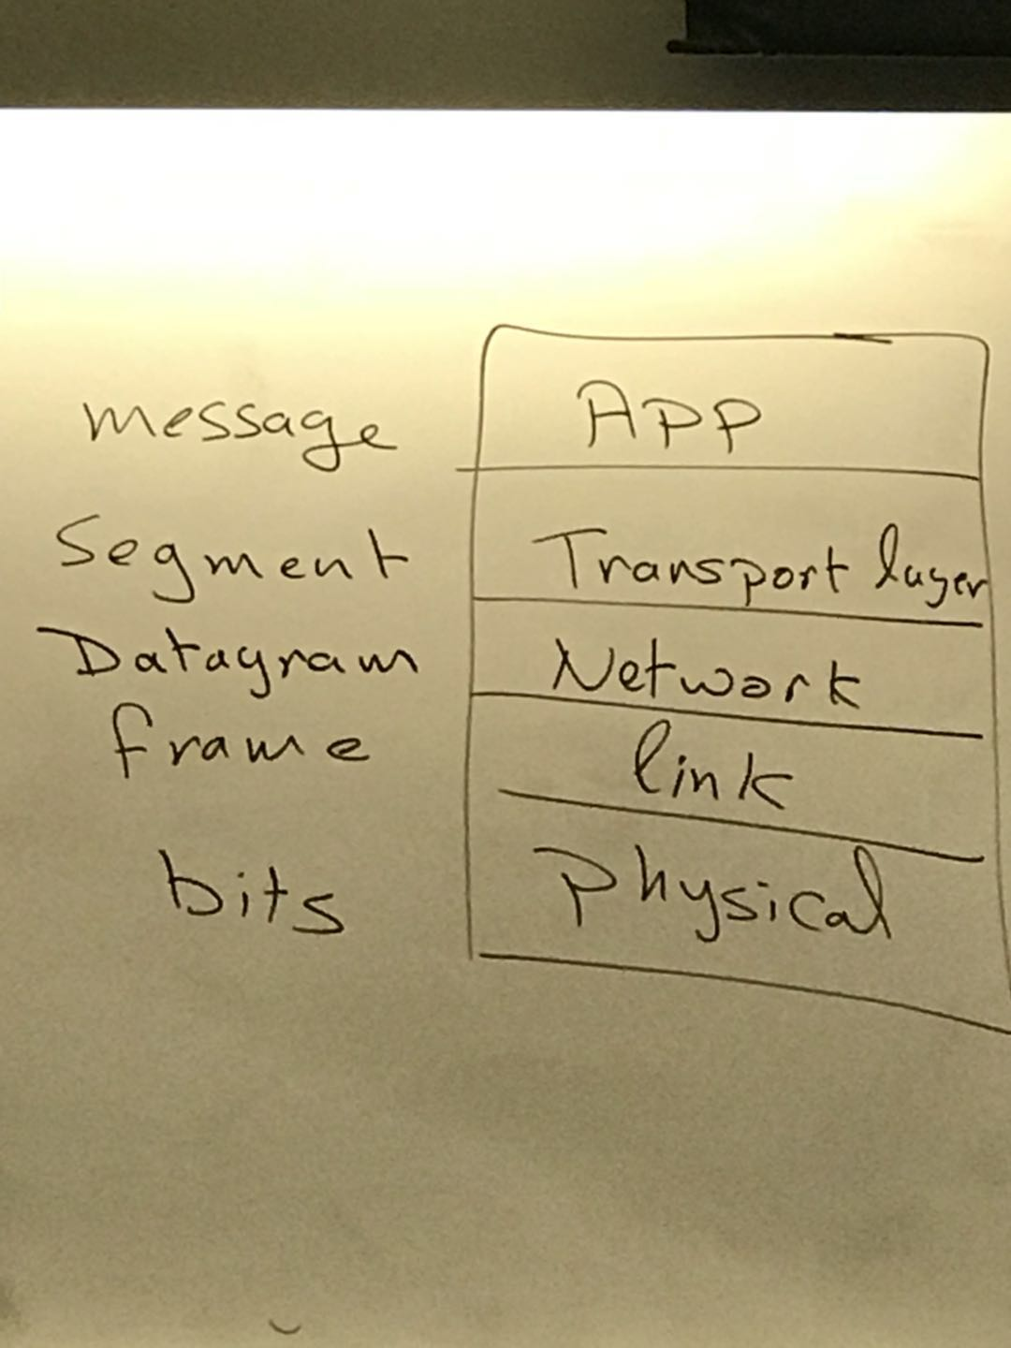

Summary